**NBSC GUIDE MAP**

Website Application

Submitted by:

Jhon Raymer A. Busano

Charl A. Cabugao

Althea Valerie G. Alguzar

Submitted to:

Cliff Amadeus Evangelio

## **Purpose of our website application**

The NBSC Guide Map is an interactive platform designed to help students, staff, and visitors navigate the various departments and facilities of Northern Bukidnon State College (NBSC). With this tool, you can easily locate important areas such as administrative offices, classrooms, laboratories, libraries, and recreational facilities.

This map aims to make your experience at NBSC more efficient and enjoyable. Whether you're new to the campus or familiar with the grounds, this guide will help you find your way quickly.

The NBSC Guide Map is a user-friendly tool that will save you time and energy, ensuring you never get lost and always know the best route to take.

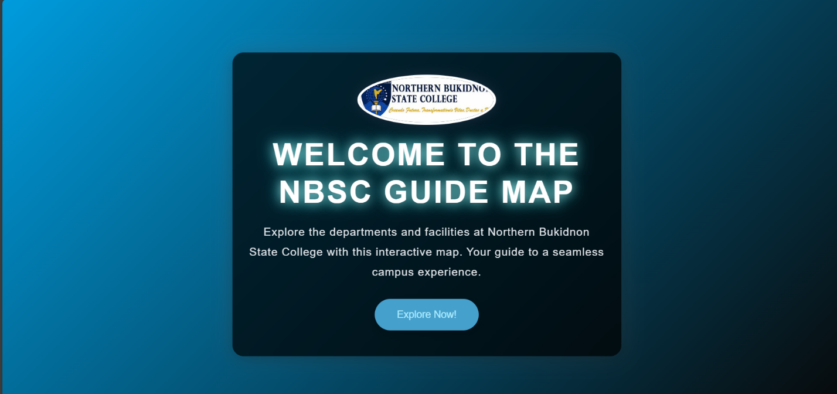

This is the Home page and you can see that there is a title of and description of our website.

**Leaflet map**: we use leaflet map to mark the location of the departments and facilities, and this is the NBSC Guide Map (Northern Bukidnon State College) The marker you can see is the location of each department and facilities of the NBSC.

Example:

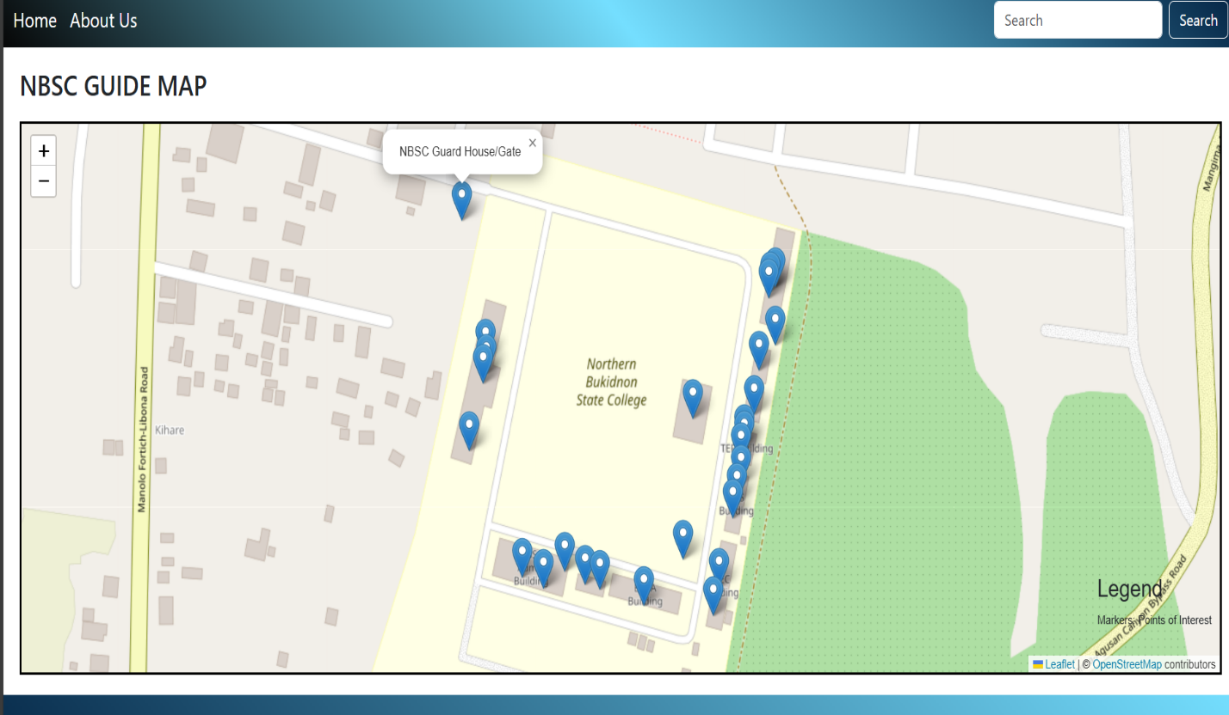

**Dynamic elements and Dynamic Cards**: We used dynamic elements to search for the locations, so if you want to find the Department or Faculty much faster, you can just search it up in the top right corner, you can see the search bar there. And if you’re going to click the marker you will see the image of the department or facility that is in that marker.

Example: 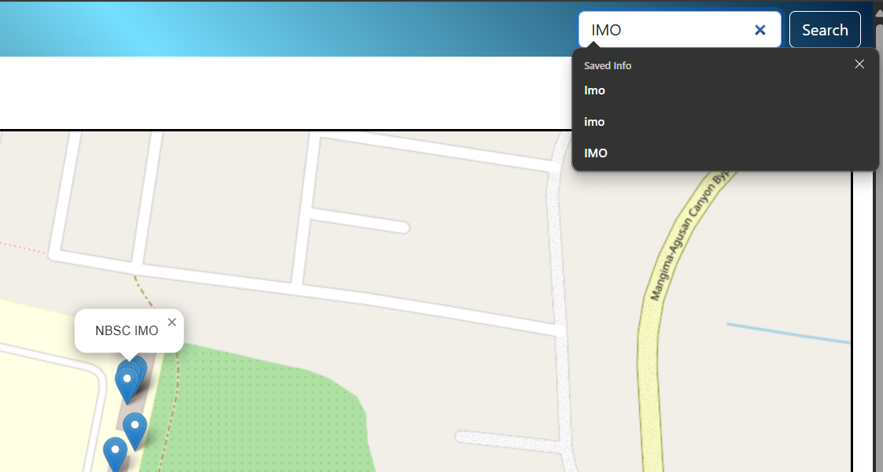

Example:

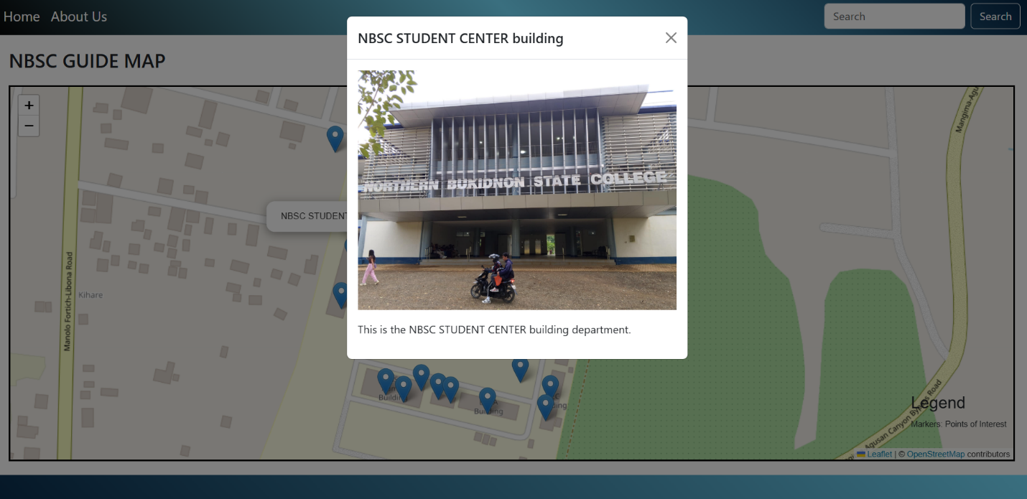

**About our website application**

